Magic Invitational Report: Ryan Fuller
Ryan Fuller
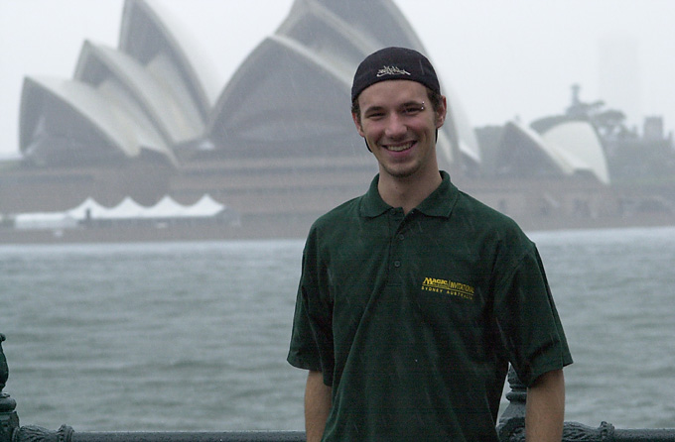
The Magic Invitational is the one tournament where playtesting is basically considered cheating, since it's all for fun... or at least I had thought so. There were a few people gunning for the win - and that upset me. I mean, I was hoping for a level playing field. Who playtests for a tournament with no cash? It's people like Gary Wise that don't want to have the worst record in history, that's who! Well, it worked out okay for him this year, since he didn't finish last. Now enough shots at "The King of Draft" himself, because after that weekend he was pretty much dethroned. I beat him in the last two Invasion drafts we played. And with some really stupid cards too. Heh.
Now to start off, Sydney is a beautiful city. Almost a mirror image of Vancouver, but really modern, as they had just hosted the Olympic Games. Unfortunately, it rained up until the day before we left.
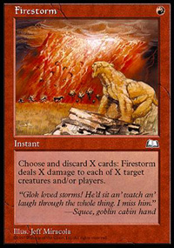
The first morning started out with me asking Mark Rosewater if I could borrow Dave Price's PT-LA deck (from the Auction of Champions) to play in the BYOB portion, and got shot down. Then I found out that BYOB didn't start until round 4, giving me some time to get my act together. Round 1, Finkel kicked my head in as I tried to take his Subterranean Spirit with Aladdin and Thran Forge. Protection from Red, hmmm, "but it's an artifact creature," I was thinking. Well, my logic failed me as I just wasn't ready for this. I lose to Zvi and beat Price. Now, I'm still deckless... when I find out that Pikula has two. So being the good guy that he is, he lends me one. I was 2-0, and then lost to Shvartsman. That guy just has my number. I was playing Ponza vs. his Sligh, and he won with one of his sideboarded Firestorms (and to me drawing nothing but junk for five clutch turns). Yeah, I think Firestorm is just the answer to Ponza. It did one point to me both times he cast it in our match. What a bargain that card is.
Now, on to the next day. Duplicate Limited was a ton of fun. In a match against my teammate Noah Boeken, I couldn't pull my fourth colour game 3 (go figure) to play all three of my splash cards in hand. That sounds flaky, but it was an ALL GOLD draft. Here's the situation. I'm at 4, he's got a Tempest Drake (2/2 flier, U/W) and a Urborg Drake (2/3 flier, U/B). I've got Plague Spores in hand, and a Cinder Shade. However only 2 of my land are Swamps. So the only way I can win is by drawing two Swamps... wrong. I cast Plague Spores pointing at the Tempest Drake. He says, 'the U/B flier?' and I look at the audience and judge Donais, and say 'Why yes Noah,' despite the fact that Plague Spores can't kill black creatures. He puts it in the graveyard, I draw the Swamp, and bust him. Everyone's laughing and Noah's just puzzled. At the end of the game, everyone bursts out laughing and then I concede the match to him. Mission accomplished - when we went for lunch, he talked no smack about beating me.
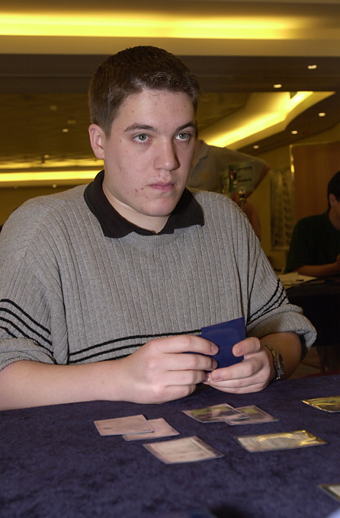
Mojo miser?
Next day I lose to Kai Budde and I never win again. Kai had stolen my mojo. A week later in Grand Prix Florence, Kai made top 4. I missed my first Top 32 at a GP. Then, he goes and wins Chicago, as I missed my first Day 2 at a PT (individuals that is) since NY-Rye ('97, I think) to break my longest Day 2 streak. And if you hadn't noticed, up to that point, Kai had been sucking hard. I already emailed Kai asking for the return of my mojo.
The evenings were pretty much a blur. I just remember going out with one of the WOTC feature match reporters (my girlfriend Jamie Lynn =) and Noah Boeken and livin' it up in Sydney. Now for those of you who don't really know Jon Finkel - that guy can live it up! Whatever, everyone got along great. Trevor 'Big Daddy' Blackwell had gone out one night and brought seven girls back to his hotel room to play poker. What a guy.
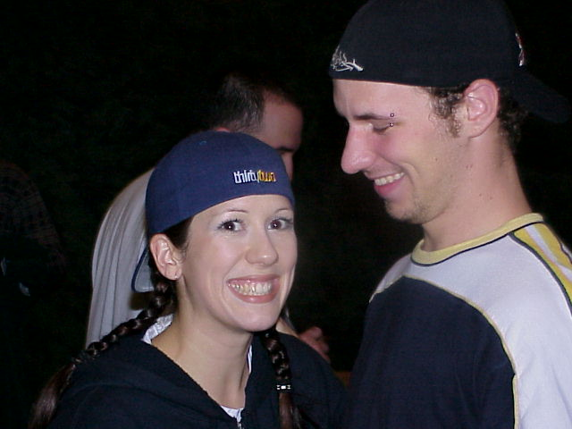
For those of you who don't know me, I was in the middle of a Magic world tour. This trip included places like Ibiza, Spain, Porto, Portugal, Amsterdam, Holland, Kyoto, Japan, Sydney, Australia, Helsinki, Finland, Budapest, Hungary, Prague, Czech Rep. and many other places. Jamie didn't know how to play until a few weeks after Worlds. She then made Top 8 at her first qualifier in Brno, Czech after only three weeks of playing. Then, when we played GP Porto she went 5-0-2 Day 1 and was the only girl to make second day. You have no idea how proud I was. She's now a Sideboard Feature Match reporter. Me and my girlfriend Jamie Lynn had been traveling since a week before the World Championships in Brussels. I'd like to thank Magic and Jamie Lynn for the best time of my life.
Chris Benafel: Sorry you couldn't make it to Sydney, we missed you there.
Ari the Icelander: Sorry we left Chicago a day early, we had plans to party =(
Jay Elarar: Watching someone grow up is the coolest thing.
Noah Boeken: Thanks, thanks thanks.
Gary Wise: As obnoxious as you are, I'm starting to find humor in you =)
Lepine, Williams, SteveOMS: We have great photos of Manchester.
Jamie Lynn: Who taught me how to live my life to the fullest.
And that's all I've got to say about that.
Ryan Fuller

